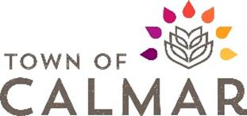 | Community Grant Program  Review Form (for Administration)

Application completeness:

- Date of application received: _______________________

- Has all the required information been submitted? Yes___ No___

If not and the window for application is still open, please contact the applicant. If complete, skip to point 4.

- Date of completed application: _______________________

- Is the organization existing ___ or new ___

- Is the organization involved in an area supported by this grant program? Yes___ No___

Financial information:

- Does the applicant have partner(s)/volunteers? Yes___ No___

- Are there other potential sources of funding besides the applicant and the Town? Yes___ No___

- Is the Grant Funding vital to the initiative? Yes___ No___

Other information:

- Date at which the RFD will be presented to Council: _______________________

- Notification to the client of presentation date: _______________________
___ email ___ phone ___ in-person

