Grants to Organizations
Application Form
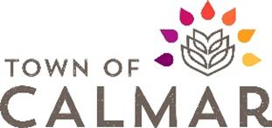
Organization Details

Name:

Mailing address:

Contact person:

Phone and
email:

Registration
number:

Number of
members:

Please provide proof of insurance with your application.

In which of the following areas is the organization involved (check all that apply)?

Arts |  | Environment
Community spirit |  | Heritage
Community well-being and/or fitness |  | Recreation
Culture

Initiative Details

Initiative name:

Initiative location,
Date, and time:

Initiative
description:

Grant amount
requested:

Are volunteers or other organizations involved?
(if yes, please described)

How will this
initiative impact
the community?

Financial Details

Please identify the anticipated expenses and revenues associated with the initiative (including the grant request amount)

Anticipated expenses | Amount ($) | Anticipated revenues | Amount ($)
Total |  | Total

If you receive less than your request, would you still be able to conduct the initiative (Please circle one): yes or no

Other Details:

- You can submit any additional information with this application, that you believe pertinent to Council’s understanding of the initiative and/or your organization.
- Submissions will be accepted between August 1st and October 31st for initiative in the upcoming year.
- Decisions will be made by the Council prior to December 31st and in conjunction with the Town’s budget adoption.
Complete application must be submitted to:
Attention: Grant Coordinator
PO Box 750, 4901 – 50 Ave, Calmar AB T0C 0V0
Or
By email at: grants@calmar.ca

